NEW A144 Dis-Eur-France-Brassempouy-Figurine-Head-Female-Venus-Ivory

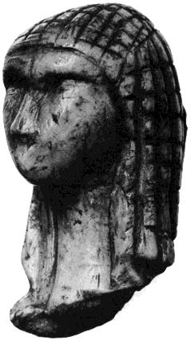

Fig. 1. France-Brassempouy-Figurine-Female-Head-Venus-Ivory-original-after Powell 1977.

**Formal Label:** France-Brassempouy-Figurine-Female-Ivory

**Display Description:** The Venus of Brassempouy belongs to the Middle Gravettian Upper Palaeolithic Culture (26,000 BP– 24,000 BP) in line with the French derived Noailles culture. This particular head is of interest because of its facial features and the plaited hairdo. It appears to have been fractured at the neck, which may have been intentional. Her face is triangular and pensive. The forehead, nose and eyebrows carved in relief are angular. The vertical crack was caused by the internal molecular structure of the ivory which is susceptible to temperature and humidity changes and which is why the figurine cannot be kept on indefinite display.

**Accession Number: A 144**

**LC Classification:** GN772.2.P4

**Date or Time Horizon:** Middle Gravettian, 26,000 BP– 24,000 BP

**Geographical Area: southeastern France**

**Map from http://latitude.to/img/latitude-logo.svg; GPS Coordinates: 43.63413 -0.69442;** 40° 26' 46" N 79° 58' 56" W.

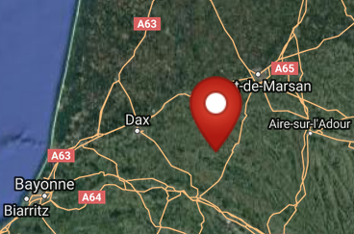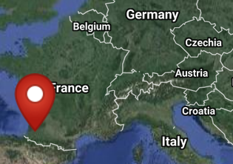

**Cultural Affiliation:**

**Medium:** mammoth ivory.

**Dimensions: original, H** 36.5 mm, D 22 mm, W 19 mm. **Weight:**

**Provenance: original in** Musée d'Archéologie Nationale at Saint-Germain-en-Laye

**Condition:** museum replica in resin.

**Discussion:** Gravettian proper begins with a single facies, dated around 28,000 BP-27,000 BP and is characterized by backed points. Middle Gravettian cultures appeared 26,000 BP: a French derived Noailles Culture, which is limited to the Tyrrhenian coastline of western Italy, and an eastern Gravettian Culture, which derives from Eastern Europe and contains lithic assemblages characterized by backed truncated pieces. In the middle are the Apennines, a borderline between Gravettian people coming from France and the ones from Eastern Europe.

**References:**

Delporte. Henri. 1980. *La grotte du Pape, station préhistorique. Il y a 20 000 ans*. Brassempouy: Association culturelle de Contis.

Powell,Thomas George Eyre. 1977. *Prehistoric Art*. London: Thames and Hudson.

Simonet, Aurélien. 2012. *Brassempouy (Landes, France), ou, La matrice gravettiene de l’Europe / Aurelien Simonet* ; publié avec le soutien du Ministérè de la Culture et de la Communication, Direction General des Patrimoines, Sous-Direction de l’Archeologie ... [et al.]. Études et récherches archéologiques de l’Université de Liège; 133. Liège: Université de Liège.